**Chomsky Normal Form (CNF)**

Sets restrictions on length of RHS

For all the productions, The elements in RHS must either be 2 variables or 1 terminal. (Eg.A -> a or A -> BC).

**Normalization of a Context-Free Grammar to Chomsky Normal Form**

Any given CFG can be converted to the Chomsky normal form.

Steps:

1. If start symbol S occurs on RHS, introduce a new symbol S’ and add a new production

S’ -> S.

1. Remove null productions
2. Remove unit productions
3. Replace each production A -> B1B2 ... Bn (n >2) with A -> B1C where C -> B2B3 ... Bn. Repeat this step for all productions having 2 or more variables on RHS.

(Eg.

A -> BCD then replace with A -> BE and E -> CD)

1. If the RHS of any production is of the form A -> aB, where a is a terminal symbol and A,B are non-terminal variables, then replace this production with A -> XB and X -> a. Repeat this step for all productions having such productions.

Eg

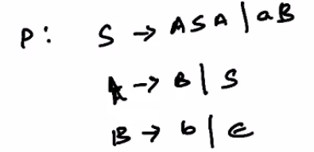

Apply step 1 to replace S in the RHS with S’.

S -> S’.

There is 1 null production B -> Epsilon, so we remove it. To do this, substitute B with Epsilon in all productions that involve B.

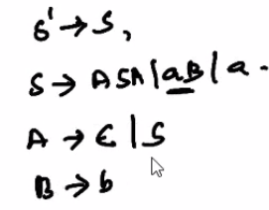

This introduces another null production A -> Epsilon, so we remove it also.

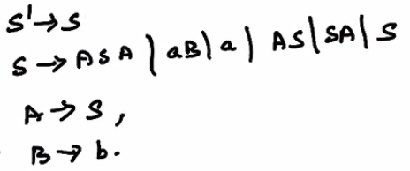

Now we go to the next step. There are 4 unit productions to be removed.

S’ -> S, S -> S, A -> S, A -> B

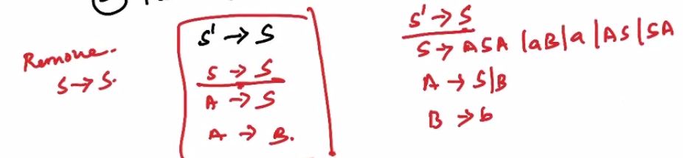

Next remove S’ -> S

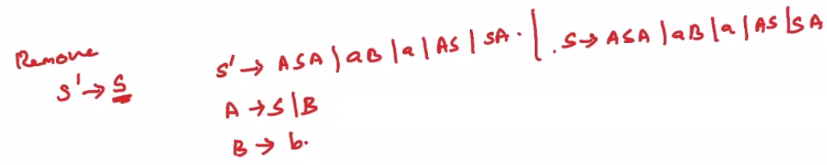

Remove A -> B

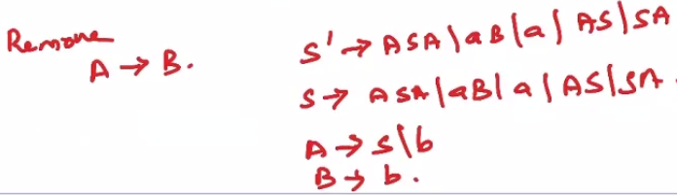

Finally remove A -> S

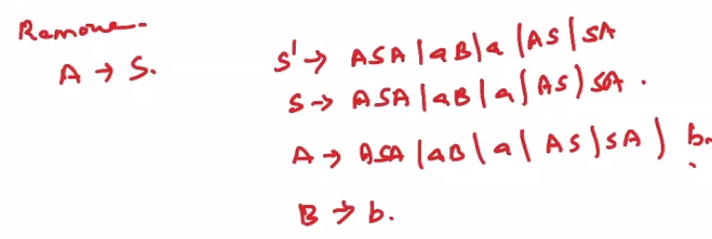

Now we go to the next step

There are 3 productions having >2 variables in RHS

S’ -> ASA, S -> ASA, A -> ASA

We need to replace these using X -> SA

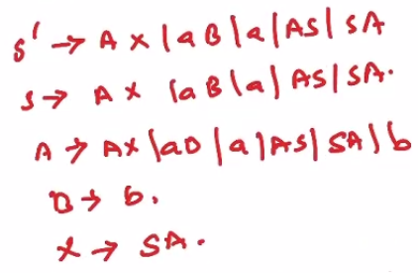

Now we move on to the last step

The productions S’ -> aB, S -> aB, A -> aB must be substituted with Y -> a

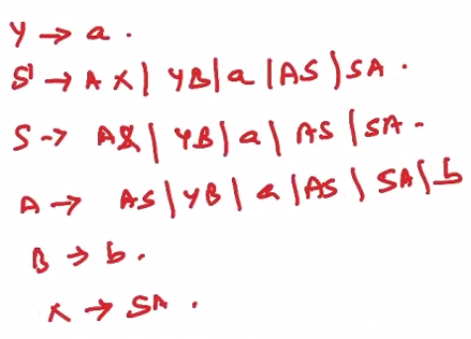

These productions are now in the Chomsky Normal Form.

**Greibach Normal Form (GNF)**

A CFG is in GNF if the productions are of the form

A -> b

A -> bC1C2 ... Cn

GNF is a generalization of the definition of Simple grammar.

**Normalization of a Context-Free grammar to Greibach Normal Form**

Steps

1. Remove unit and null productions
2. Check if the CFG is in Chomsky Normal Form. If it is not, normalize it to CNF.
3. Introduce new variables Ai, and change the names of the non-terminal variables into some Ai in ascending order of i.
4. Check if the non-terminals are in ascending order, such that if the productions are of the form Ai -> Ajx then i < j and should never be i >= j. (eg A1 -> A3A2 is acceptable, but A4 -> A4A3 is not acceptable.)